Overdale Community Primary School – EYFS Autumn Term 1 2023
Theme: Who am I? (TRANSITION AND BASELINE FOR FIRST TWO WEEKS)
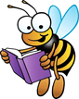  Specific Area: Literacy  Focus Texts – The Squeaky Story  We will begin to learn Phase 2 phonics  We will learn to orally blend and segment  We will practise writing CVC words and tricky words using our Phase 2 phonics  We will practise letter formation and name writing  We will be using Talk For Writing to develop our story telling and to create our own stories  We will be labelling body parts, write about who is in our family and identify initial sounds  We will learn new vocabulary with Word Aware  We will share a variety of topical books, non-fiction books, alongside reading for pleasure. |  | Specific Area: Mathematics  White Rose Maths – Getting to know you, match, sort and compare, measure and patterns, it’s me 1, 2, 3  We will begin by focusing on numeral recognition, subitising, representing, counting, ordering and shape recognition  We will match, sort and compare amounts. We will also create our own sorting rules  We will compare size and quantities, mass and capacity.  We will explore and create simple patterns, continue repeated patterns, make patterns with our bodies and  spot mistakes  We will recognise, subitise, represent and sort numbers 1, 2, and 3  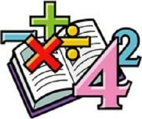  We will form these numerals and explore how they are composed  We will find 1 more and 1 less, and link this to 1p and 2p, how we can add/takeaway to make different amounts  We will explore numbers 1 to 3 in relation to time (identifying numbers on a clock)  We will be learning about 2D shapes with 1 to 3 sides and positional language
Specific Area: Knowledge and Understanding of the World  We will be practising using an iPad to take photographs and to open QR codes to read books and access educational apps  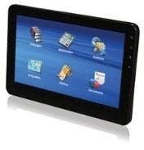  We will be looking at similarities and differences between people and their lifestyles, including how we can celebrate differences  We will be learning about different festivals around the world including Harvest festival and Bonfire night  We will be using our body and our senses  We will be discussing people that are important to us and our houses and homes, including going on a journey to explore different environments | Who am I?  BIG QUESTION  What makes me me? |  | Specific Area: Personal and Social Development (PSED)  We will be learning about ourselves and others, including things about us that are similar and things that are different  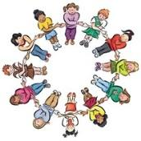  We will think about what makes us special and what our own strengths are  We will talk about those people that are important to us and think about the value of our relationships  We will identify and name parts of our bodies and how to keep healthy  We will identify our feelings and introduce the Colour Monster as a way to support children in recognising and coping with different emotions
Specific Area: Physical Development  This half term we will be focusing on how to get changed for PE  We will begin to develop fundamental movement skills and think about how we can negotiate space, balance and manipulate objects  We will learn about how we can look after our bodies, including healthy feelings and eating habits  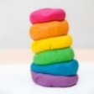  In literacy we will be practising our handwriting and making sure  that we get the size and shape of the letters correct  We will be developing our fine motor skills through activities  such as pen disco, dough disco alongside developing scissor skills | Prime Area: Communication and  Language  We will be focusing on our speaking and listening skills – taking turns to speak and listening to each other  We will also be focusing on our oral blending skills and listening to sounds in words  We will learn new vocabulary with Word Aware  We will communicate our own stories |  | Specific Area: Expressive Arts and Design Music  This half term we are going to be focusing on self-portraits, we will enhance these by exploring different materials  We will be learning simple rhymes and songs about ourselves and our bodies  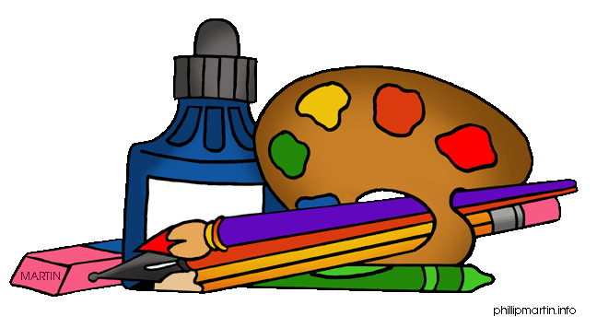  We will be retelling and putting actions to our stories  We will create collages of our homes and develop simple family trees  We will bake and celebrate Harvest festival

Phonics – Your child will bring home a weekly phonics guide to help you at home with how your child learns to say and write the letters they have been learning in class.
Reading - Children will be expected to read their home reading books at least three times a week with a written comment from a parent in their reading record.
Books will be changed once a week, but your child’s book bag needs to be in school every day please – thank you for your support
Dojo profiles – Please remember to send us photos and videos of what your child is doing at home – anything from walking the dog, swimming, playing in the play park,
baking etc – we can’t wait to see your photos

